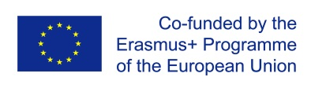
The project Erasmus+ «Enhancing Capacity of Universities to Initiate and to Participate in Clusters Development on Innovation and Sustainability Principles” (UniClaD) is actively working.The partners from the Central Ukrainian National Technical University, presented by Vice-Rector for Research Oleksandr Levchenko, Associate Professor of General Agriculture Сhair Larisa Salo, Associate Professor of Rural Engineering Сhair Leshchenko S., senior lecturer at the Department of Economics, Management and Business Ilona Tsarenko as well as students in the specialties: Agronomy, Agroengineering and Public Administration have visited one of the enterprises of Kirovograd region - PE Vlad". During the meeting with the owner of the enterprise Demchenko V. The issues of scientific cooperation of the university in the direction of topical issues of the need to introduce innovative solutions and technologies in the agricultural sphere were discussed. The administration of the enterprise conducted an interview with students about thei rparticipation in the project and discussed the approximate topics of final qualifying works.
